**ARTIFICIAL INTELLIGENCE**

**MIN MAX ALGORITHM**

**AIM:** To implement min-max algorithm using Python.

**ALGORITHM:**

* Construct the complete game tree.
* Evaluate scores for leaves using the evaluation function.
* Back-up scores from leaves to root, considering the player type:
  + For max player, select the child with the maximum score.
  + For min player, select the child with the minimum score.
* At the root node, choose the node with maximum value and perform the corresponding move.

**CODE:**

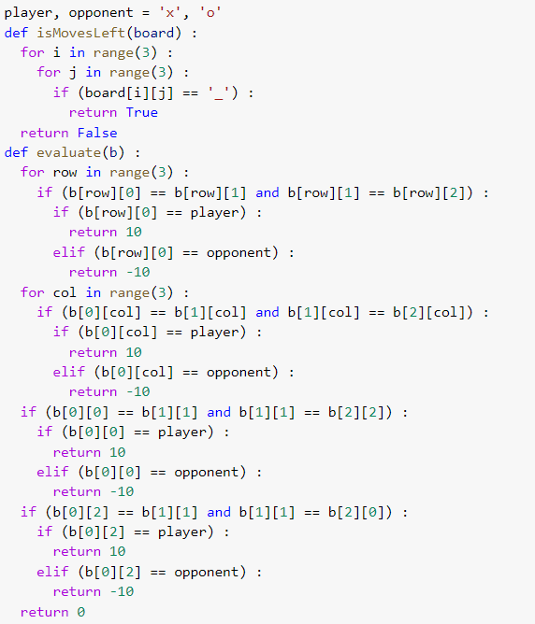



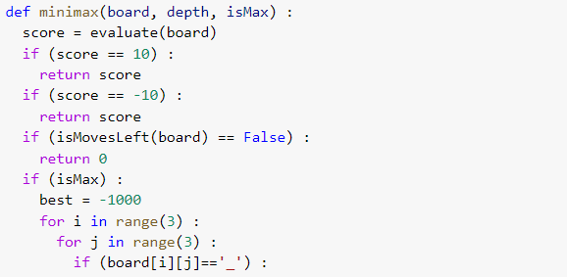

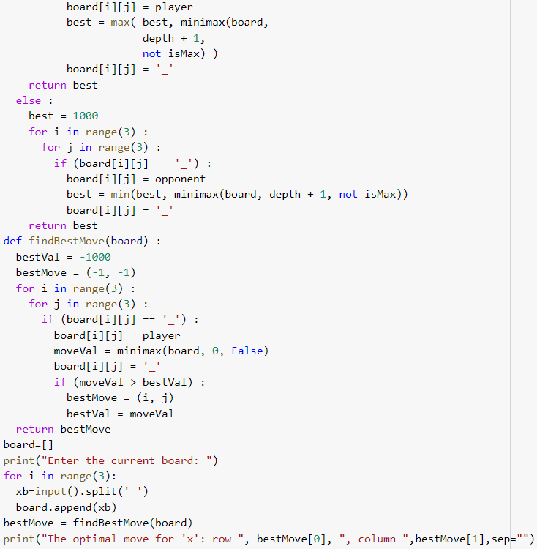



**OUTPUT:**

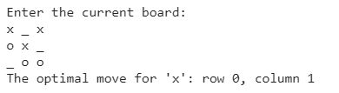

**RESULT:** The code for implementing min-max algorithm was written and executed in Python successfully.